Final Project Report
Smart Energy Consumption Analysis
Project Title: “ Smart Energy Consumption Analysis and Prediction using Machine Learning ”.
Documented by:M.Saikumar

1.Introduction:
The increasing use of electrical appliances and the lack of clear information about energy usage often lead to energy wastage, higher electricity bills, and inefficient use of devices. Traditional electricity billing systems only show total monthly consumption and do not explain which appliances consume more power or how energy is used over time.
This project proposes a Smart Energy Consumption Analysis System that monitors electricity usage for each device and analyzes energy consumption patterns over time. The system uses the SmartHome Energy Monitoring Dataset, which contains timestamp-based, device-level power data collected over six months.
Machine learning techniques such as Long Short-Term Memory (LSTM) for time-series forecasting and Linear Regression as a baseline model are used to analyze and predict future energy consumption. The system also provides interactive visualizations, energy-saving suggestions, and a web-based dashboard developed using Flask, HTML, CSS, and JavaScript.
Module-1: focuses on defining the project objectives and collecting the Smart Home Energy Monitoring Dataset. The data is checked for missing timestamps and basic inconsistencies, and organized by devices and time to understand energy usage patterns.
Module 2: prepares the data for machine learning by handling missing values and outliers. Timestamps are formatted properly, data is resampled, energy values are scaled, and the dataset is split into training and testing sets.

2.About Dataset:
This dataset provides detailed, time-based, device-level energy consumption information, which is useful for analyzing usage patterns, identifying high-energy-consuming appliances, and building machine learning models for energy prediction.The dataset contains 100,000 rows and 8 columns.
Each row represents the energy consumption of a specific appliance at a particular time in a household.
Columns:
- Home ID: Identifies each house uniquely.
- Appliance Type: Shows the type of device consuming electricity.
- Energy Consumption (kWh): Amount of energy used by the appliance in kilowatt-hours.
- Time: Time at which the energy usage was recorded.
- Date: Date of the energy consumption record.
- Outdoor Temperature (°C): Temperature outside the house at that time.
- Season: Season during which the data was recorded (e.g., Summer, Winter).
- Household Size: Number of people living in the house.

3.Loading the Dataset:
The dataset is loaded using the pandas library in Python. After loading the data into a DataFrame, the first five rows are displayed to understand the structure, column names, and sample values in the dataset. Similarly, the last five rows are printed to verify the ending records and ensure the data has been loaded correctly. This step helps in getting a quick overview of the dataset before performing further analysis and cleaning.

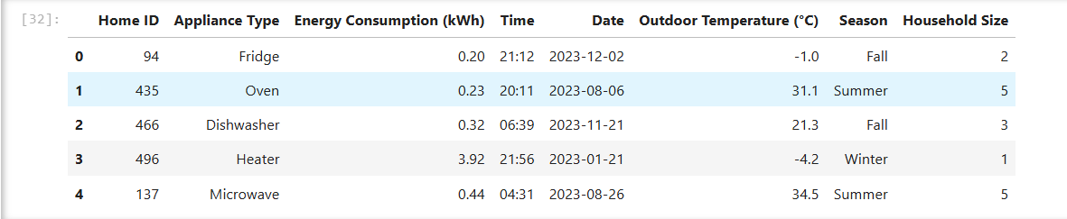
Fig.First five rows of a dataset

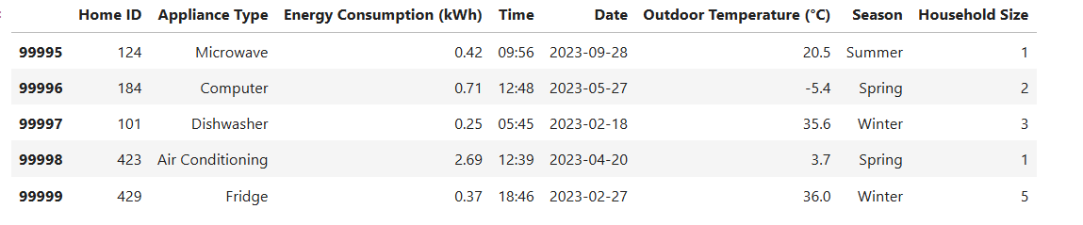
Fig.Last five rows of a dataset

4.Checking Duplicates and Null Values:
Checking for duplicate values and null (missing) values is an important step in data preprocessing because they can affect the accuracy of analysis and machine learning models. Duplicate records can cause the same data to be counted multiple times, leading to incorrect results. Null values can create errors during calculations and model training if they are not handled properly.
In this dataset, the checks show that there are no duplicate records and no null values. This means the data is clean, complete, and reliable, and it can be safely used for further analysis and model development without additional correction.

5. Visualization – Total Energy Consumption by Appliance:
This bar chart is drawn between two columns:
- X-axis: Appliance Type
- Y-axis: Energy Consumption (kWh) (total energy used)
The visualization shows the total energy consumption of each appliance by summing energy usage values for every appliance type.
Observations
- Air Conditioning and Heater consume the highest amount of energy, making them the most power-intensive appliances.
- Appliances like Dishwasher, Lights, Oven, Washing Machine, Microwave, Computer, and TV show moderate energy consumption.
- The Fridge consumes the least total energy compared to other appliances.
- This visualization clearly helps identify high energy-consuming appliances, which can be targeted for energy-saving measures.
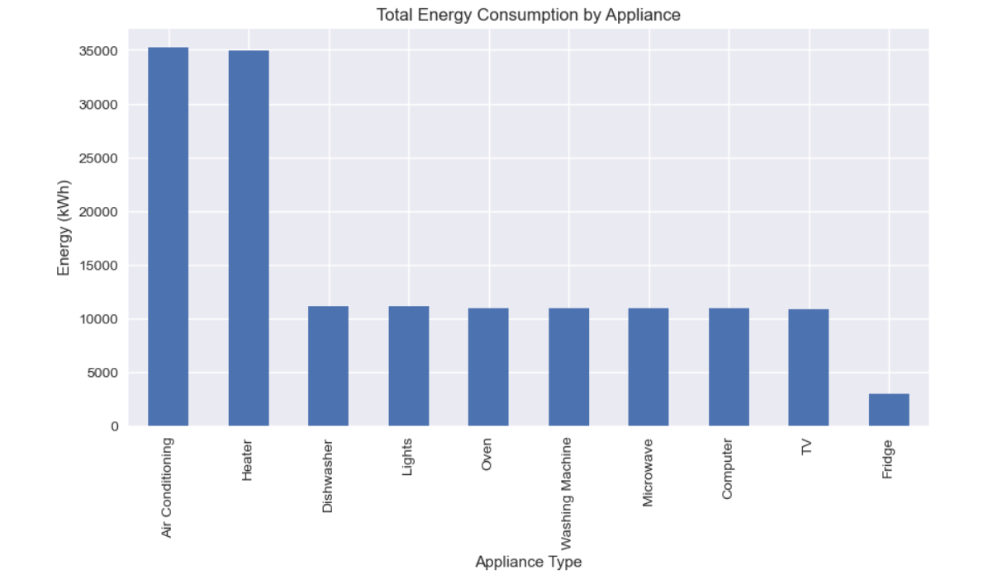

6.Energy Consumption Distribution:
This histogram shows the distribution of energy consumption values in the dataset.
- The X-axis represents Energy Consumption (kWh).
- The Y-axis shows the count, meaning how many times each energy value occurs.
Observations
- Most of the energy consumption values are low, mainly between 0 and 2 kWh.
- This indicates that most appliances consume a small amount of energy most of the time.
- Fewer readings are seen at higher energy values (above 2 kWh), which means high energy usage occurs less frequently.
- The distribution is right-skewed, showing occasional high energy consumption events.

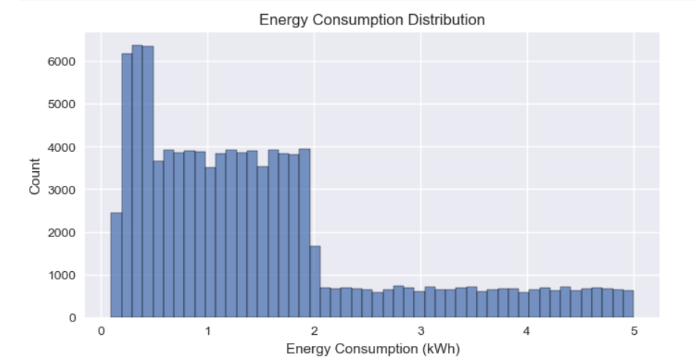

7.Timestamp:
A timestamp was created by combining the Date and Time columns into a single datetime column. This helps represent the exact moment when energy consumption was recorded. Creating a timestamp makes the data easier to analyze over time and is especially useful for time-series analysis, visualizations, and building prediction models.

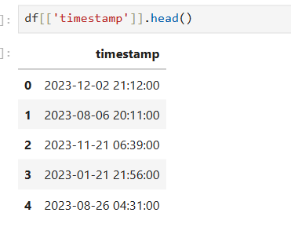
Fig:First five timestamps

Module 3: Feature Engineering
In this module, we extracted meaningful time-based features such as hour, day, week, and month to capture daily and seasonal energy usage trends. We aggregated device-level consumption statistics (mean, max, total usage) to understand appliance-wise behavior. Lag features and moving averages were created to capture temporal dependencies and smooth fluctuations in time-series data. These engineered features improved pattern recognition for machine learning models. The final structured feature set was cleaned, normalized, and prepared as input for forecasting models.
Key Outcomes: The dataset became more informative, trend-aware, and suitable for accurate prediction.

Module 4: Baseline Model Development
In this module, implemented Linear Regression as the baseline forecasting model to predict energy consumption. The model was trained on engineered features and evaluated using MAE (Mean Absolute Error) and RMSE (Root Mean Square Error) metrics. We plotted actual vs. predicted energy usage graphs to visually analyze performance. The baseline model provided a simple and interpretable benchmark for comparison with advanced models like LSTM. Key Outcomes: The key outcome was establishing a performance reference point to measure improvements from more complex models.

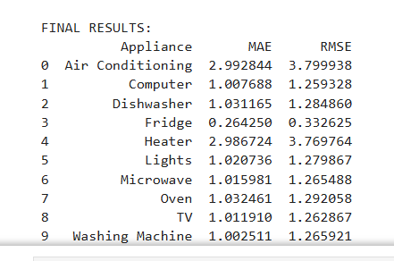

Module 5: LSTM Model Development
In this module, designed and implemented an LSTM (Long Short-Term Memory) architecture using TensorFlow and Keras for time-series energy prediction. The model was trained using sequential energy consumption data to capture long-term temporal dependencies. We performed hyperparameter tuning such as adjusting batch size, number of epochs, and learning rate to improve prediction accuracy. The LSTM model was then evaluated and compared with the Linear Regression baseline.
Key outcome :It improved forecasting performance, especially in capturing seasonal and trend-based variations. This module demonstrated the advantage of deep learning for sequential energy data.
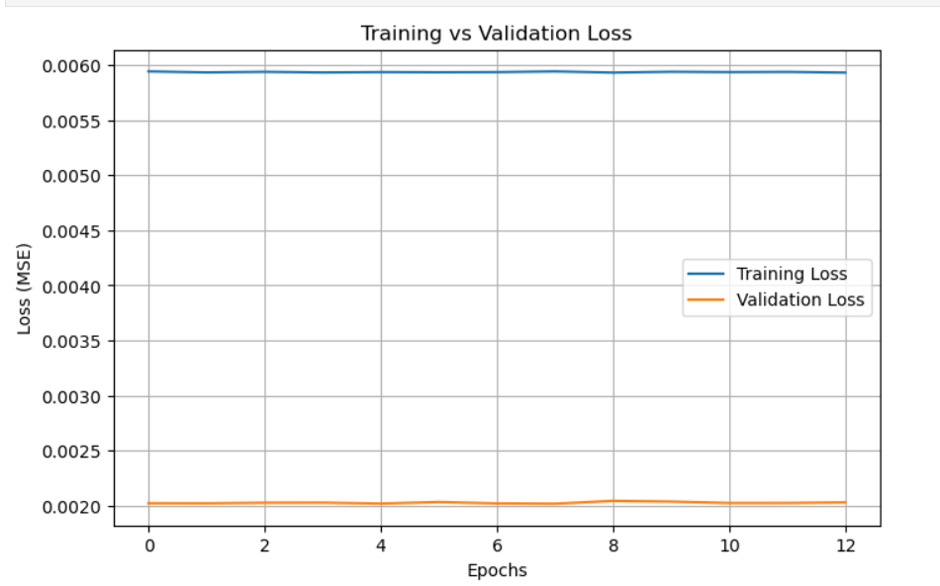

Module 6: Model Evaluation and Integration
In this module, evaluated both the baseline Linear Regression model and the LSTM model using RMSE, MAE, and R² score to measure prediction accuracy and goodness of fit. After comparing the results, the best-performing model was selected as the LSTM because the RMSE value of LSTM was lower than the RMSE value of Linear Regression. Since RMSE measures the average magnitude of prediction errors, a lower RMSE indicates better accuracy and fewer large deviations from actual energy consumption values. The LSTM model was able to capture time-dependent patterns and seasonal variations more effectively, which improved forecasting performance.
Based on this comparison, the trained weights of the LSTM model were saved for deployment. The selected model was then integrated into a Flask-compatible prediction function using Flask for real-time usage. We tested the system using sample inputs to ensure accurate and stable predictions.
Key outcomes: successful deployment-ready integration of the LSTM model into the web application, enabling users to obtain reliable real-time energy consumption forecasts through the dashboard.

Module 7: Dashboard and Visualization:
In this module, built interactive dashboard components to display hourly, daily, weekly, and monthly energy consumption trends. Device-wise usage charts were generated using Matplotlib for clear visual representation of appliance-level insights. We integrated a smart suggestions feature that provides energy efficiency tips based on consumption patterns. The dashboard was designed to be user-friendly and visually appealing. Key outcomes included improved data interpretability and better decision-making support for users. The visualization layer transformed raw predictions into meaningful and actionable insights.

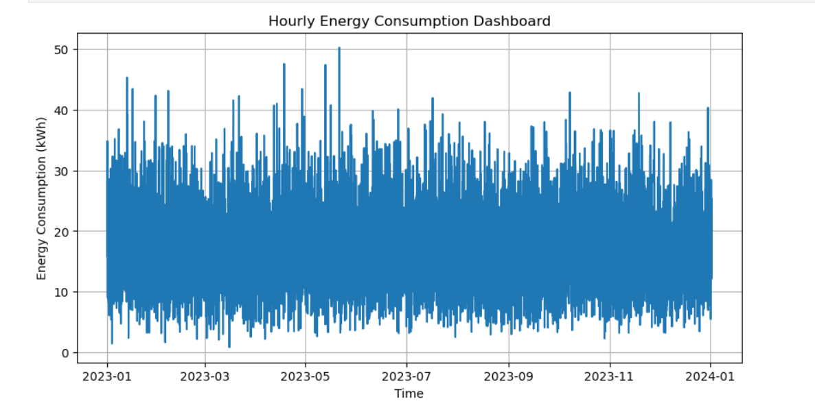

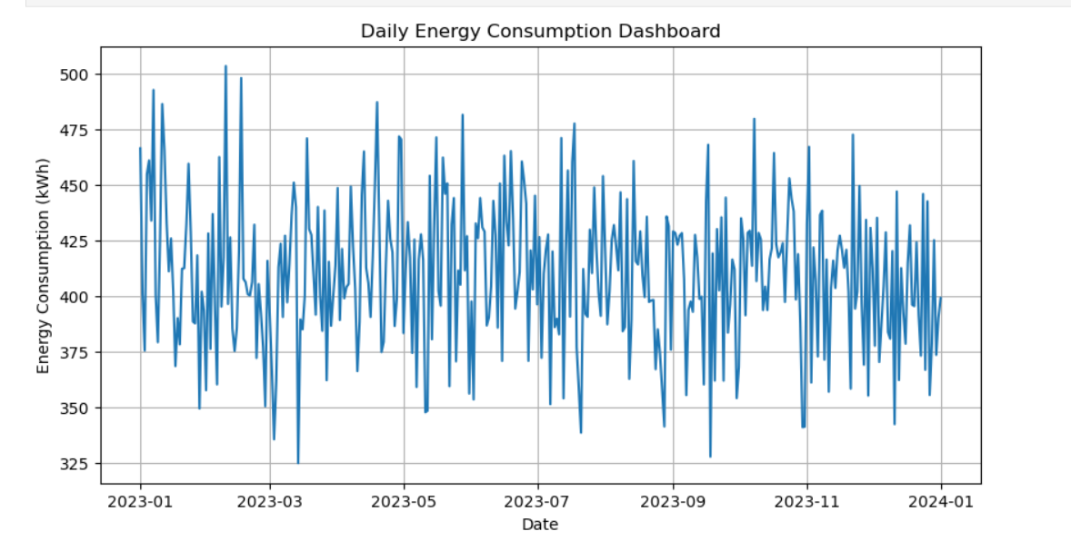

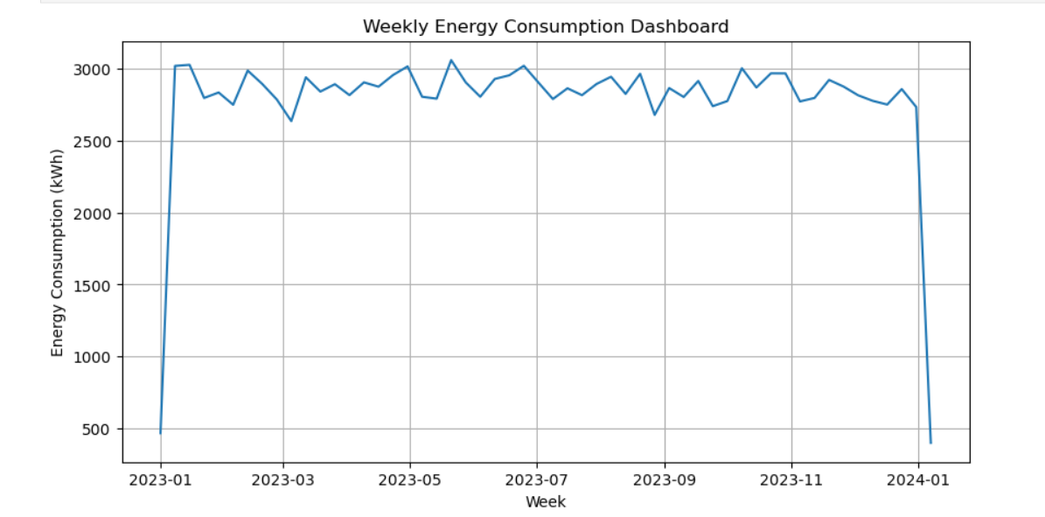

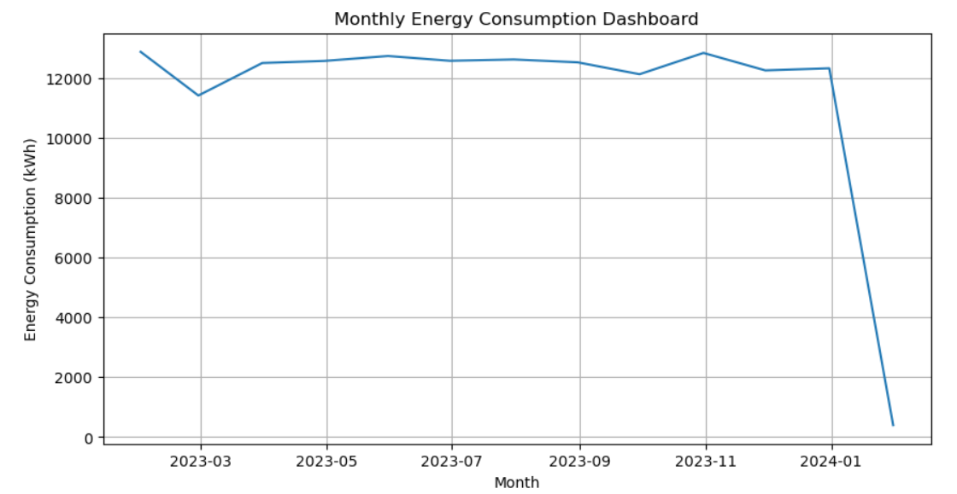

Module 8: Web Application Deployment
In this module, developed a backend API using Flask to connect the frontend interface with the trained ML model. An interactive web interface was built using HTML, CSS, and JavaScript for smooth user interaction. The web application was deployed on a local host environment (and optionally cloud) for real-time accessibility. We conducted functional testing and validated prediction outputs to ensure reliability. Finally, we prepared comprehensive documentation, testing reports, and a detailed result summary. The key outcome was a fully functional, deployable Smart Energy Consumption Analysis system ready for demonstration and evaluation
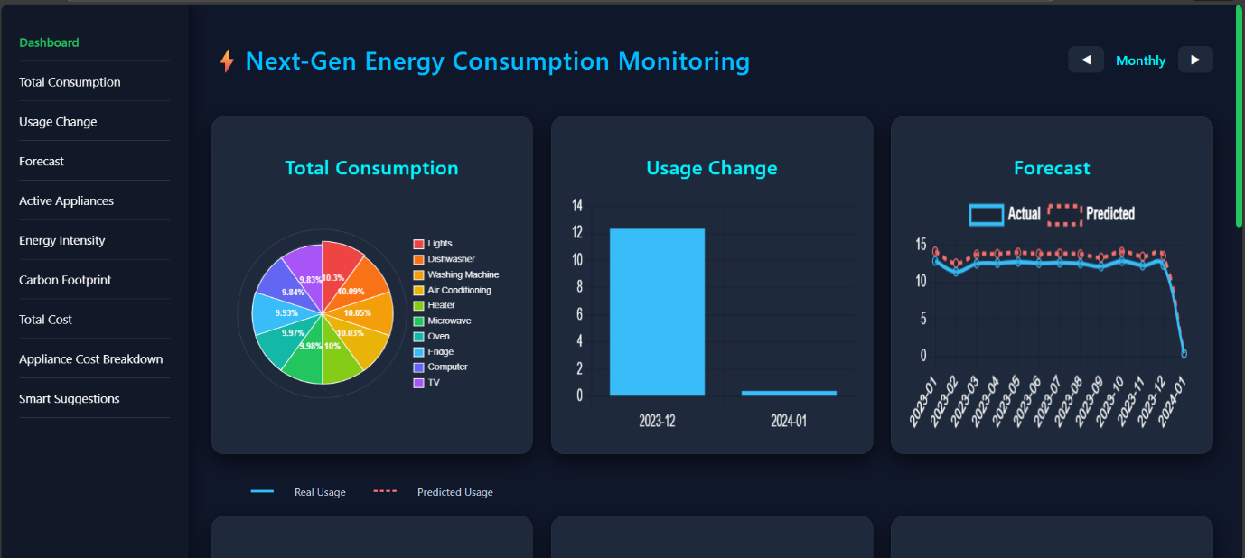
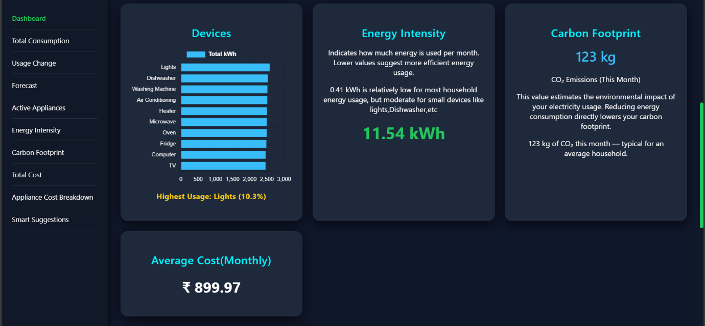

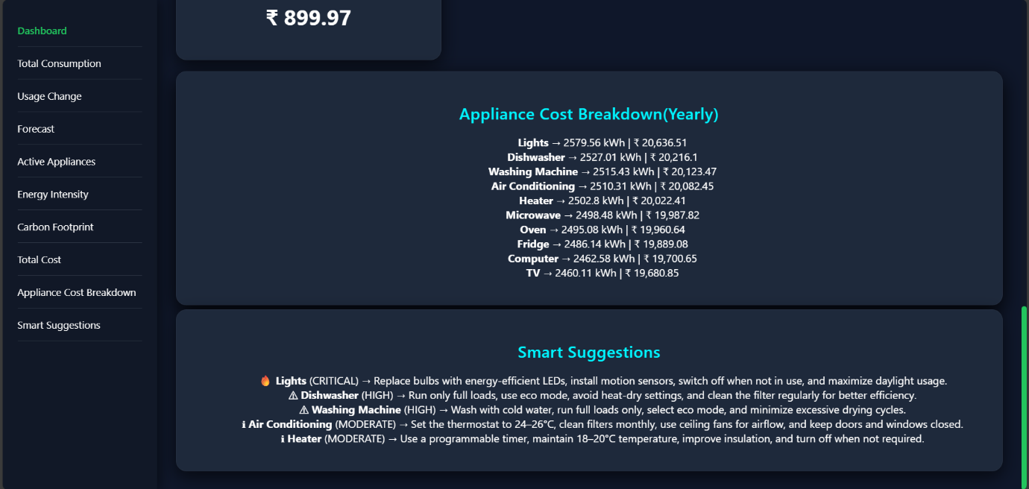

sssssSystem Architecture:
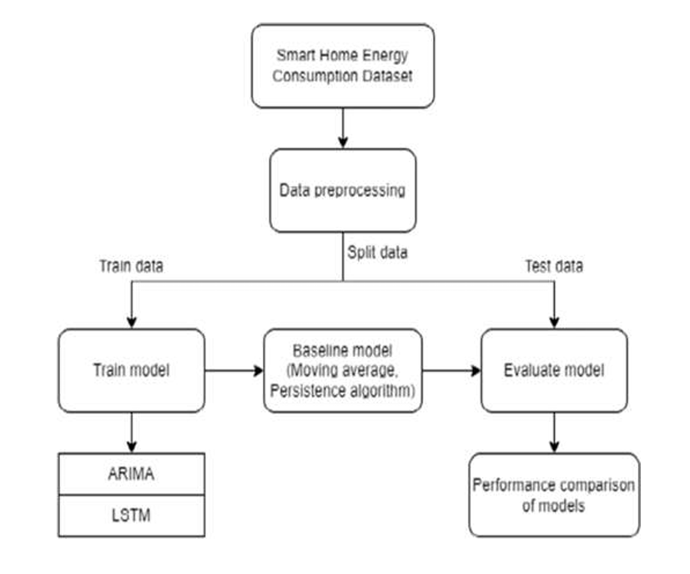

Conclusion:
This project designed and implemented a complete end-to-end Smart Energy Consumption Analysis system, starting from data preprocessing and feature engineering to model development, evaluation, and web deployment. Time-based features, lag variables, and device-level statistics were engineered to enhance prediction capability. A baseline Linear Regression model was developed and compared with an LSTM model, where LSTM achieved better performance due to its ability to capture temporal dependencies in sequential energy data.
The best-performing model was integrated into a web application using Flask, enabling real-time energy consumption forecasting. An interactive dashboard was built to visualize hourly, daily, weekly, and monthly trends along with device-wise insights and smart energy-saving suggestions.
The final system not only predicts future energy usage accurately but also helps users understand consumption patterns, reduce electricity bills, and promote energy-efficient behavior. This project demonstrates the practical application of machine learning and deep learning techniques in solving real-world energy management problems.

